SAS & Tough Mudder Training Blog 2

So, the first week of training complete, and wow what a week that was.

The training side of things open my eyes a little to where my conditioning level is, for example the video attached, pull ups I’ve never been great with any way, but can grind out 10, but this workout was 5 reps at the end of every round of these powerbag burpees rounds being 21reps first round then 18-15-12-9 till eventually 5 reps. Safe to say my arms were useless after that. 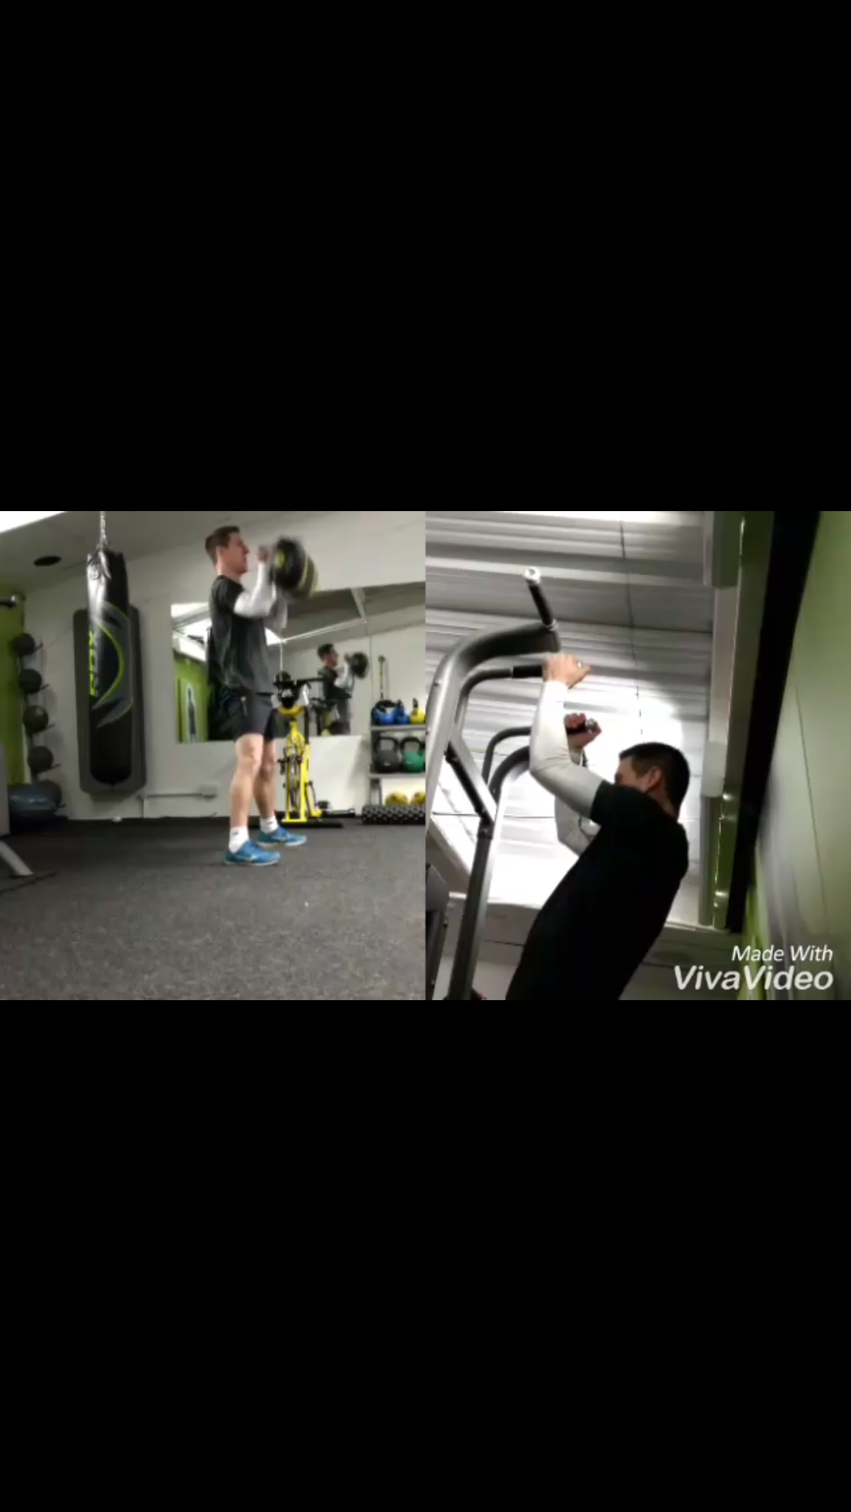

Here’s a look at the training programme I’ve started with.

|  |  |  |  |
| --- | --- | --- | --- |
|  | Workout 1 | Workout 2 | Workout 3 |
| Warm ups | 250m Row  10 x KB Swing  10x Burpee  *3 Rounds* | 1 k Row  5 x Pull Ups  10x Push Ups  15x Squats  *3 Rounds* | 400m Jog  400m Run  400m Sprint  15x Jumping Squats  *2 rounds* |
| Strength | Bench Press  Bent Over Row  Hammer curl to Press  Lat Raise | Back Squat  Split Squat  Hanging Leg raise  Nordic Leg Curls | Sumo Deadlift  Push Press  Renegade Row  Pull ups |
| Conditioning | 20 Box Jumps  20 KB Swings  20 Press Ups  3 x round for time | 5 Pull Ups  10 Press Ups  14 Renegade Rows  18mins continuous | 10 Push Press  10 Burpees  10 Hanging Leg Raises  5 x rounds for time |

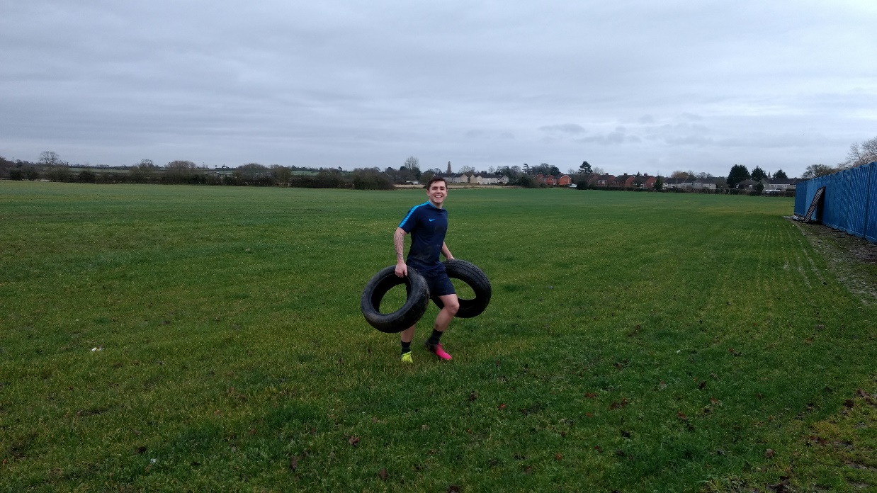Still feeling my way through it, all sessions should start with a bit of mobility work, stop me feeling too bad the following day. As well as including 2 runs a week and a couple of extra full body conditioning sessions.

Fortunately, my brother is doing the SAS event with me so we’ve already had a couple of awesome outdoor training sessions together.

It has certainly been a change of styles for me, my strength work I have kept it simple otherwise my energy is drained when doing the conditioning after. I do look at upping the conditioning a lot over time, but I must ensure my body is happy with this 5 - 6 days a week.

Next step is to get my food intake on point…

Dean